IMPLEMENTING WEB APPLICATION
Create UI to interact with Application
Date | 05.11.2022
Team ID | PNT2022TMID48220
Project Name | Inventory Management System for Retailers
Coding for Simple User Interface
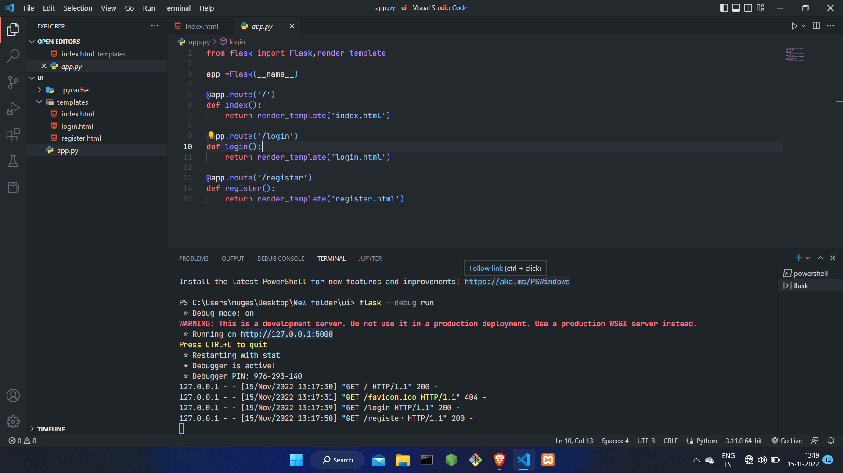
Index page
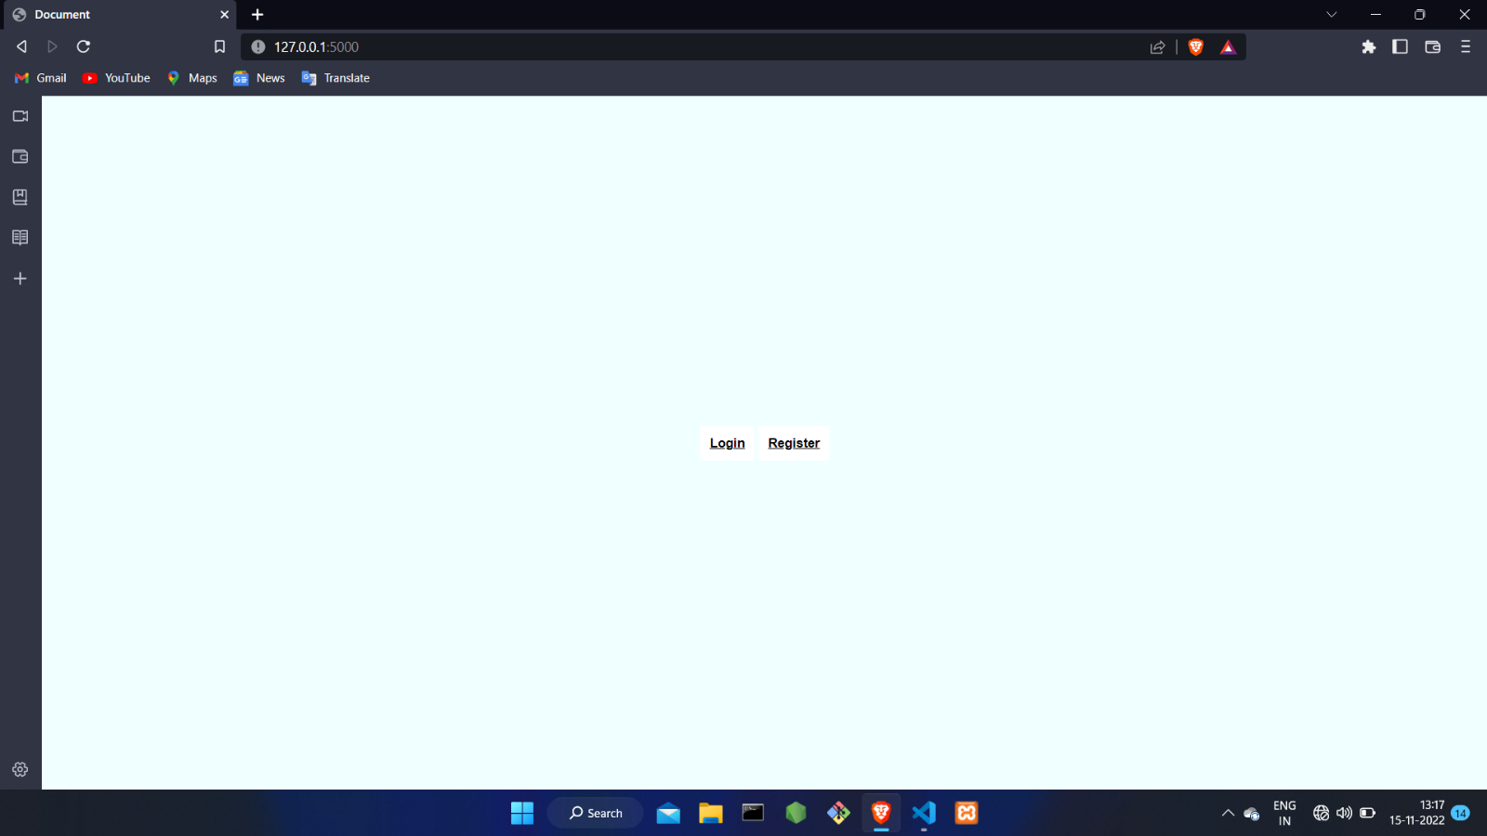

Registration Page
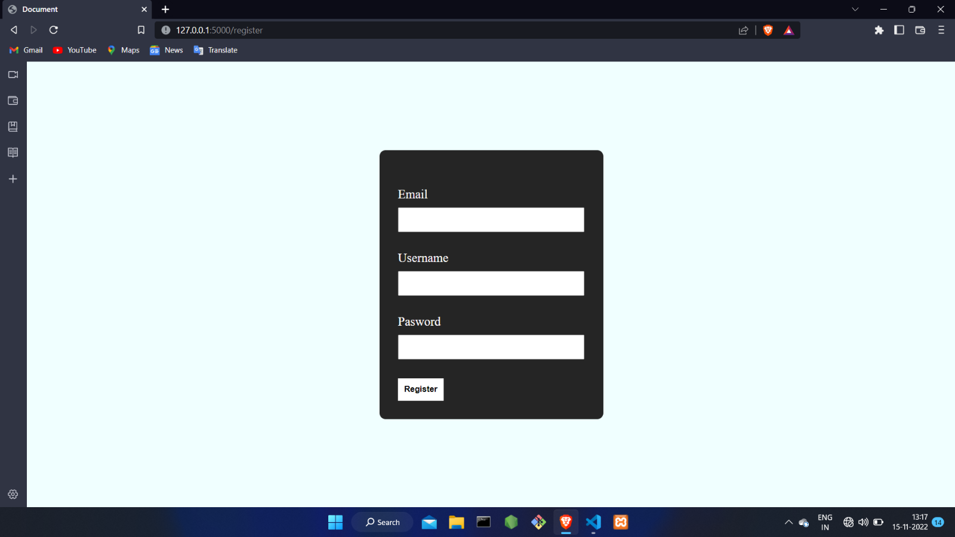

Login Page 